**Name: Debjyoti Sarkar Sumonta**

**Student ID: 22341019**

**CSE370 Section 2**

Task 1:

CREATE TABLE Developers(

member_id INT,

name VARCHAR(255),

email VARCHAR(255),

influence_count INT,

Joining_date DATE,

multiplier INT

);

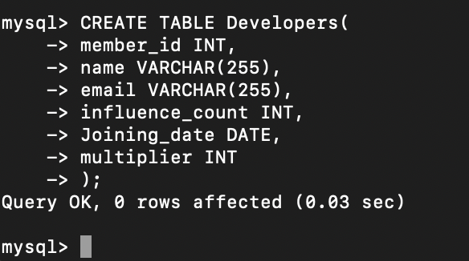

INSERT INTO Developers(member_id,name,email,influence_count,Joining_date,multiplier)

VALUES

(1,'Taylor Otwell', 'otwell@laravel.com', 739360, '2020-6-10',10),

(2,'Ryan Dahl', 'ryan@nodejs.org', 633632, '2020-04-22', 10),

(3,'Brendan Eich','eich@javascript.com' ,939570, '2020-05-07', 8),

(4,'Evan You','you@vuejs.org', 982630,'2020-06-11', 7),

(5,'Rasmus Lerdorf', 'lerdorf@php.net', 937927 ,'2020-06-3', 8),

(6,'Guido van Rossum', 'guido@python.org', 968827, '2020-07-18', 19),

(7,'Adrian Holovaty', 'adrian@djangoproject.com', 570724 ,'2020-05-07', 5),

(8,'Simon Willison', 'simon@djangoproject.com', 864615, '2020-04-30',4),

(9,'James Gosling', 'james@java.com', 719491, '2020-05-18',5),

(10,'Rod Johnson', 'rod@spring.io', 601744, '2020-05-18', 7),

(11,'Satoshi Nakamoto', 'nakamoto@blockchain.com', 630488, '2020-05-10', 10);

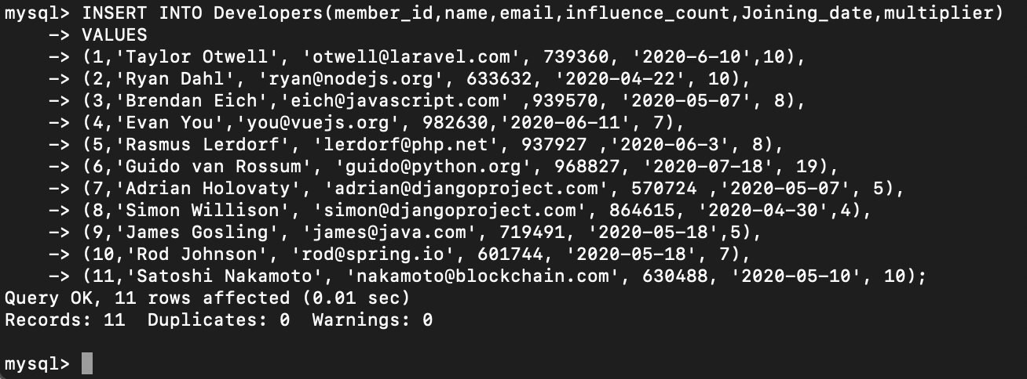

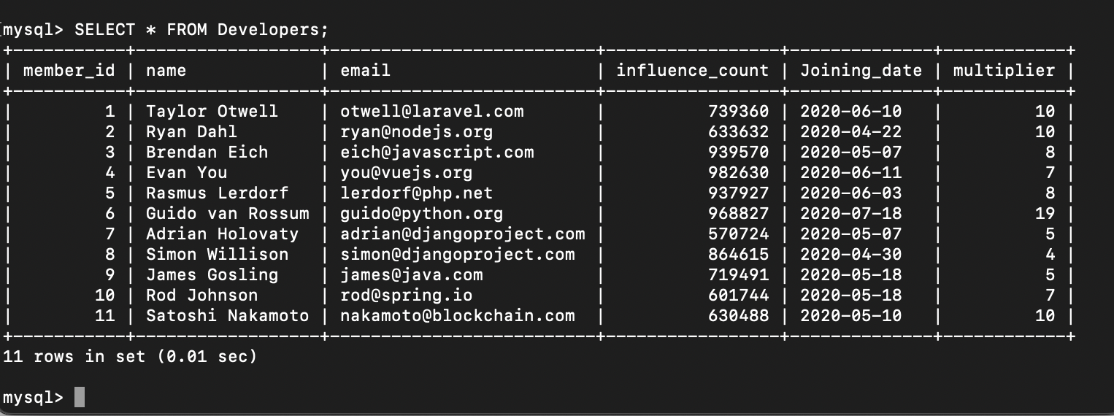

Task 2:

ALTER TABLE Developers RENAME COLUMN influence_count to followers;

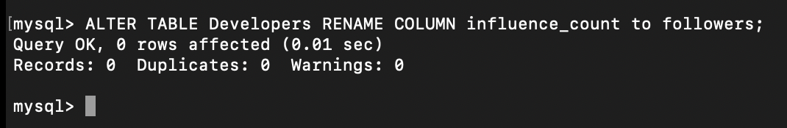

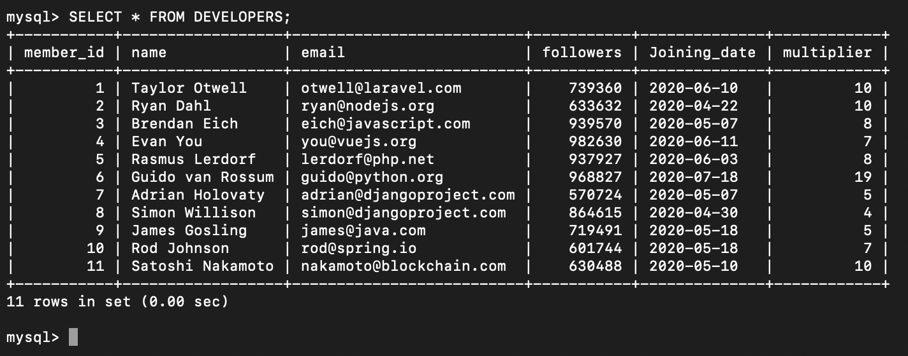

Task 3:

UPDATE Developers

SET followers = followers + 10;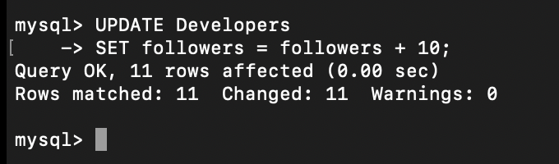

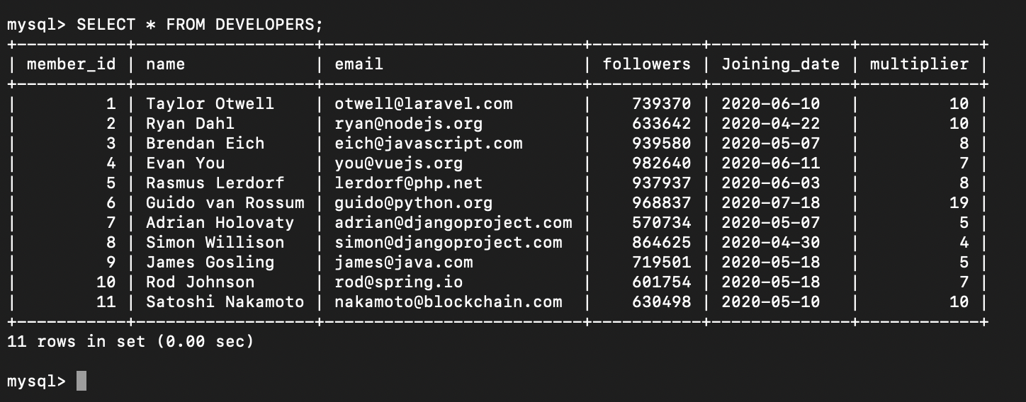

Task 4:

ALTER TABLE Developers

ADD Efficiency DOUBLE;

UPDATE Developers

SET Efficiency = (((followers*100/1000000) * (multiplier*100/20))/100);

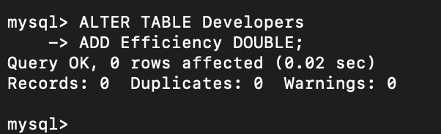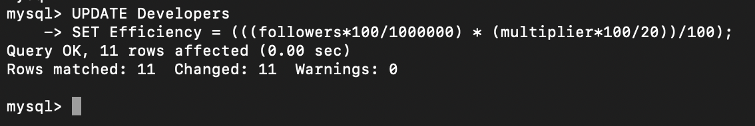

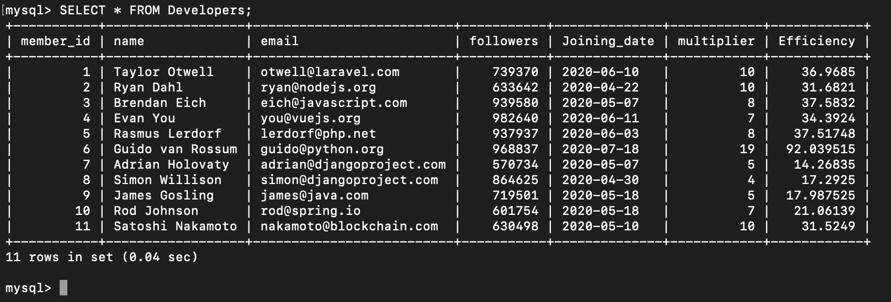

Task 5:

SELECT UPPER(name) FROM Developers

ORDER BY Joining_date DESC;

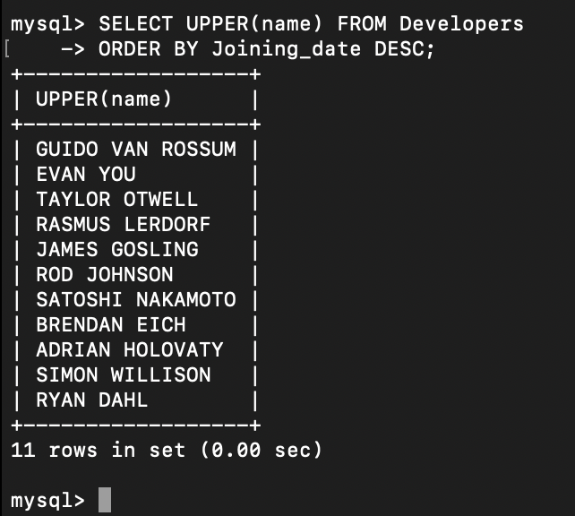

Task 6:

SELECT member_id, name, email, followers

FROM Developers

WHERE email LIKE '%.com' OR email LIKE '%.net';

